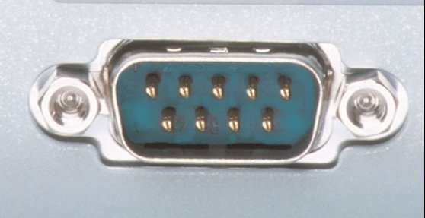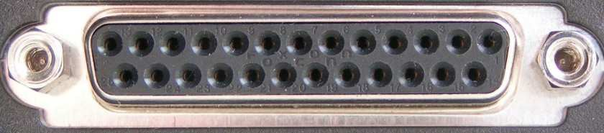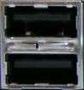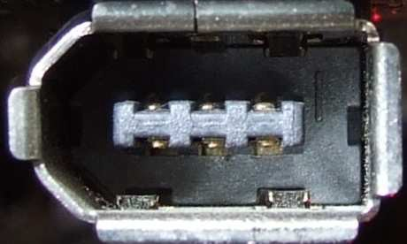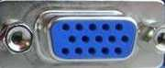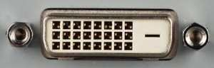

**Puertos externos del PC**

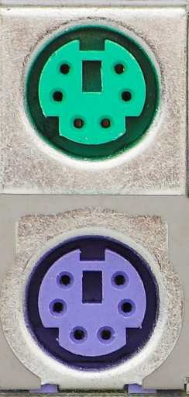

|  |  |
| --- | --- |
|  | Puerto para ratón (verde) y teclado (violeta)/ps2 |
|  | Puerto serial(rs232) |
|  | Puerto paralelo (lpt1 impresora) |
|  | Puerto USB |
|  | Firewire |
|  | Joystick (Raton vintage) (puerto serie) |
|  | Puerto vga |
|  | Puerto Dvi |

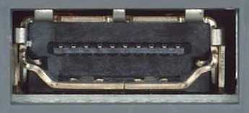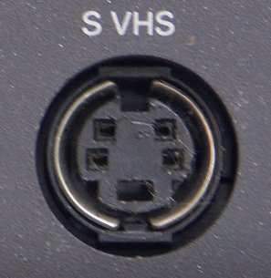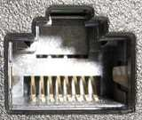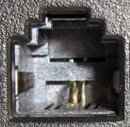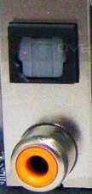

|  |  |
| --- | --- |
|  | hdmi |
|  | Puerto s video |
|  | Ethernet (rj 45) |
|  | Puerto modem (rj 11) |
|  | (panel de audio) jack |
|  | spdif |